Live in Art Deco Style at Country Club Court
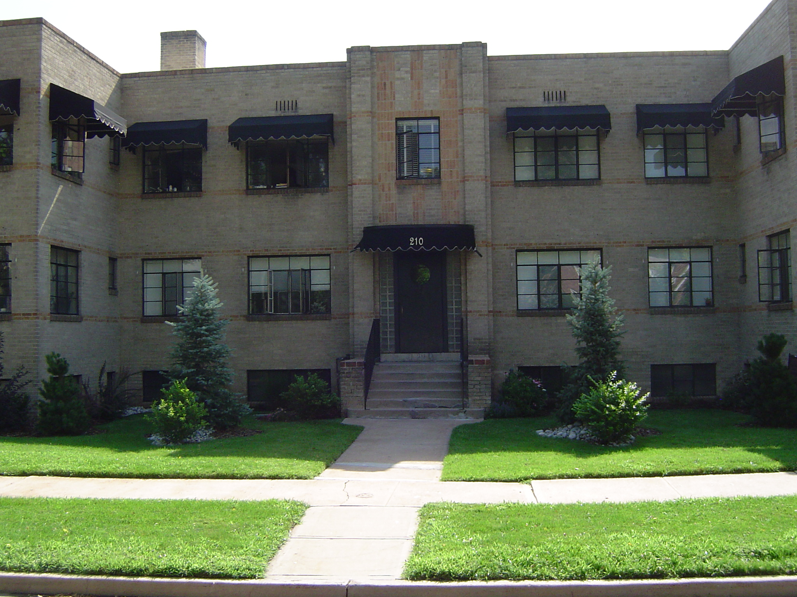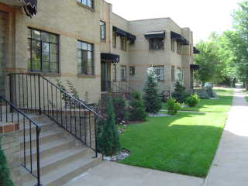
707 E. 2nd Avenue & 200-220 Washington St.

Country Club Court is situated on the border of Denver Country Club and Washington Park Neighborhoods, just blocks from Alamo Placita Park, Washington Park, and the exclusive Cherry Creek shopping district. Residents enjoy this premier Denver location which offers easy access to downtown. Classic Art Deco style makes Country Club Court a rare find!
Building features:
- Custom designed landscaping
- Deco style lighting
- Restored common areas featuring new carpet and paint
- Controlled access building
- Onsite Laundry
- Storage lockers
- Non-smoking building & apartments
- Garage Parking Available
- Rent includes all utilities except electricity

Apartments feature:
- Beautiful hardwood floors
- Designer paint schemes, new lighting
- Fabulous kitchens with new black/white flooring, and new appliances
- Abundant closet space
- Original Brass & Crystal door knobs with Art Deco hardware
- Large windows allow for lots of natural light
- Vintage Art Deco Tile in Bathrooms

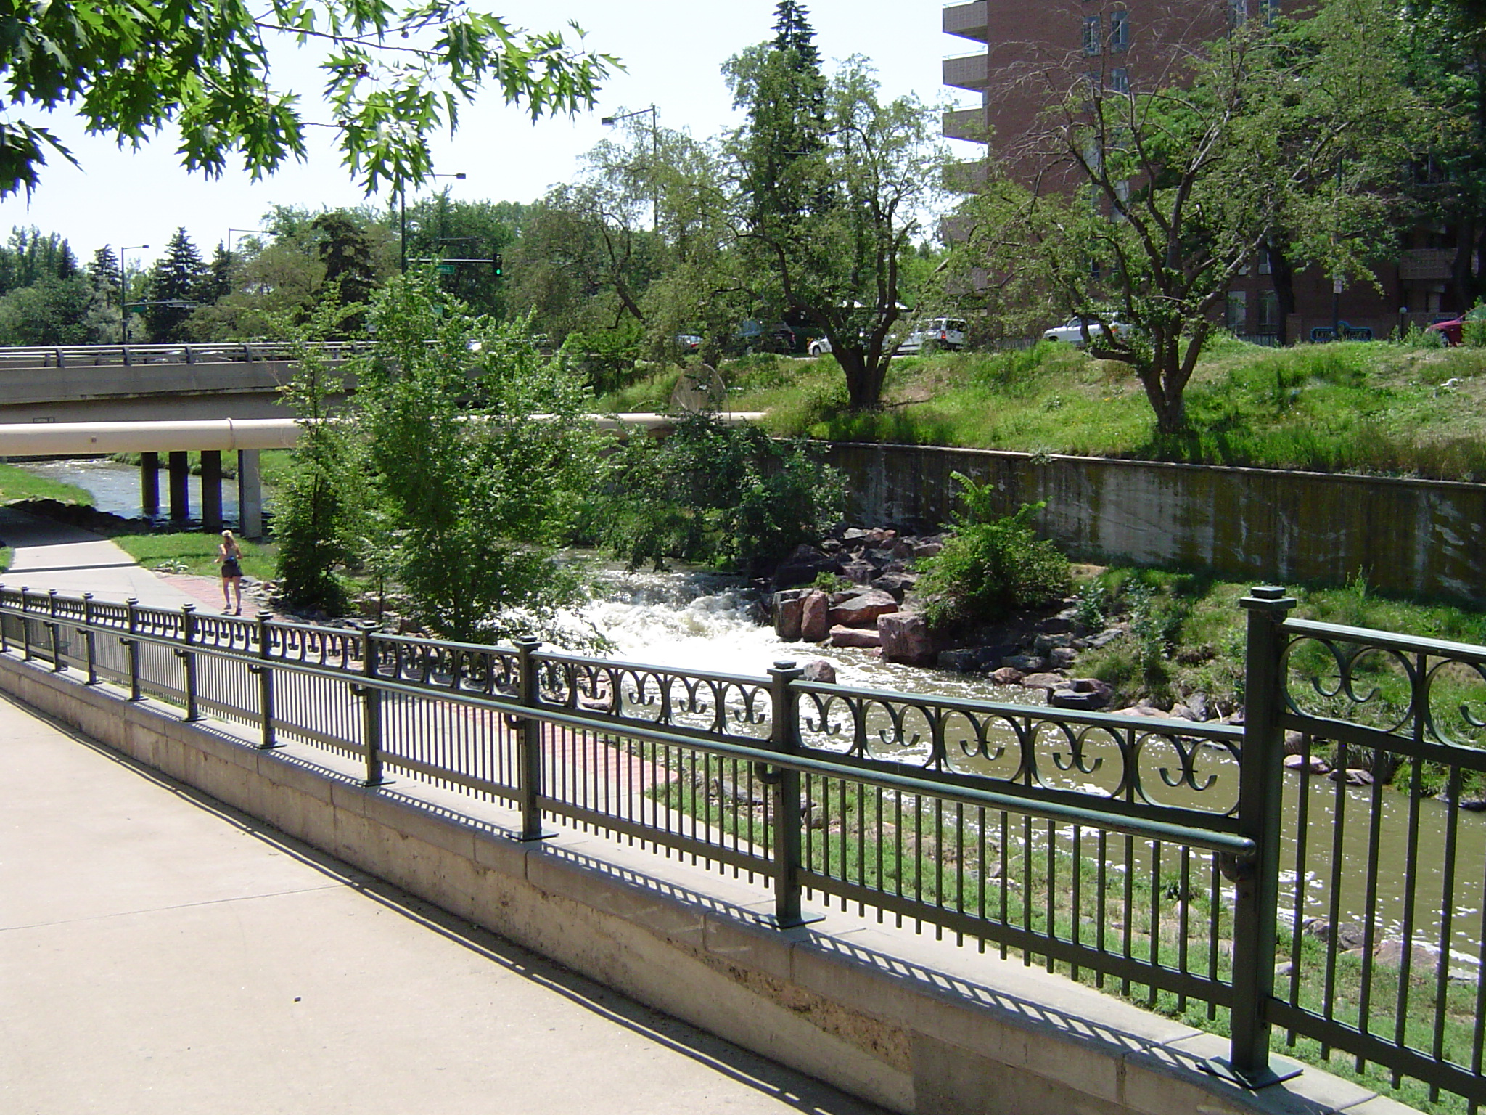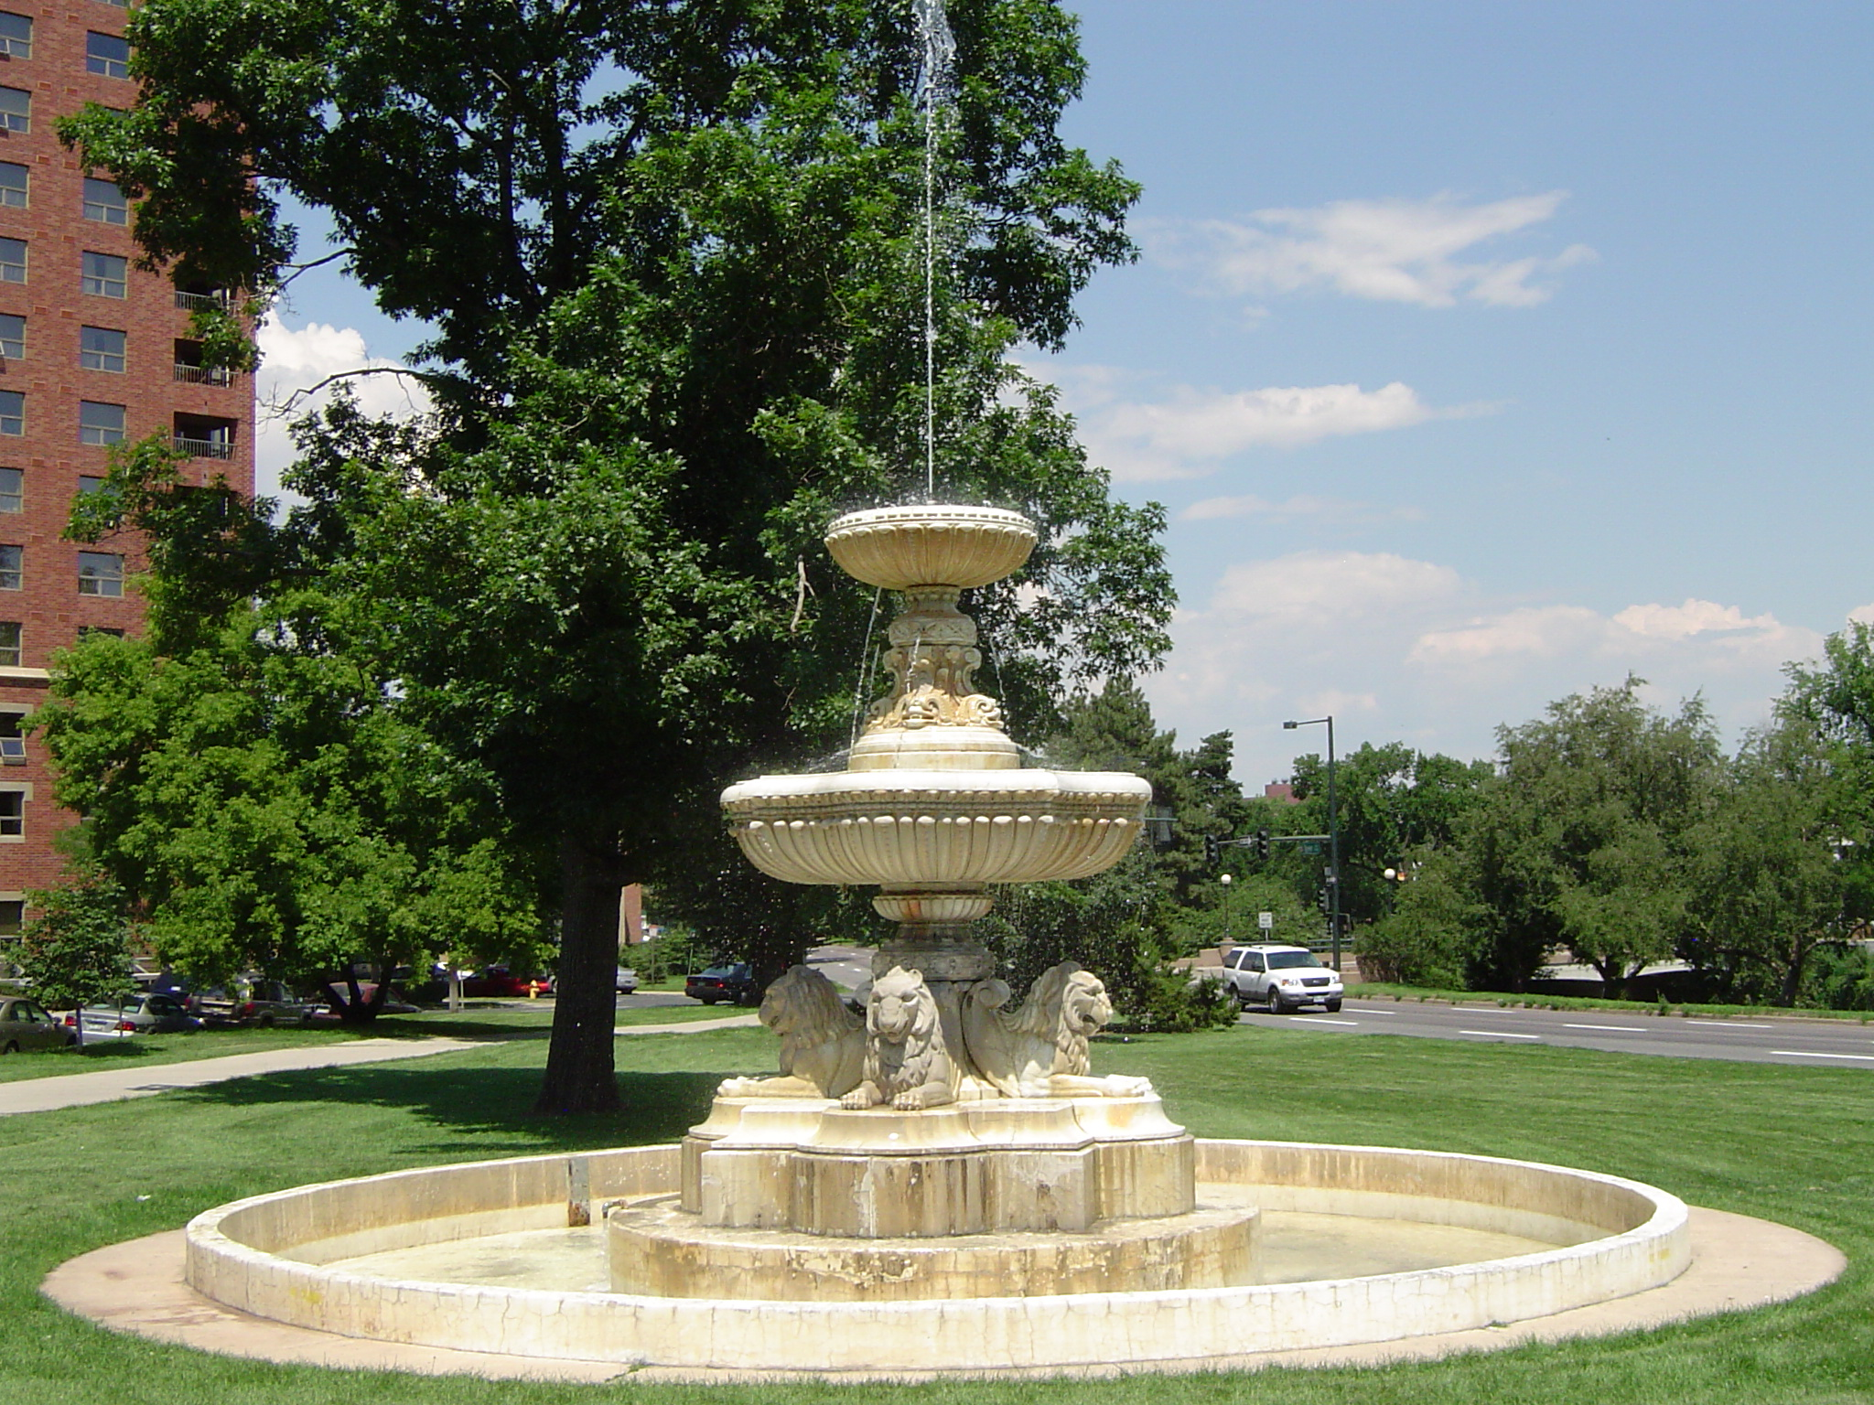

Posh historic apartments in premier location
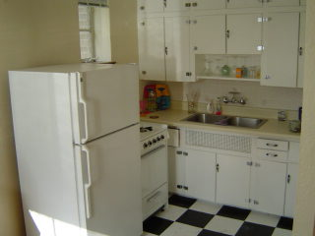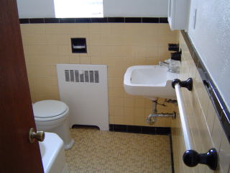

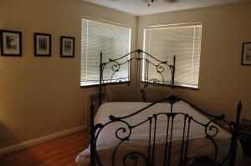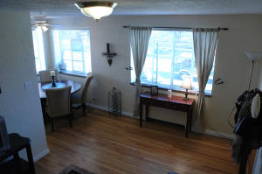

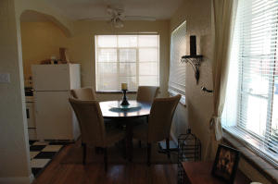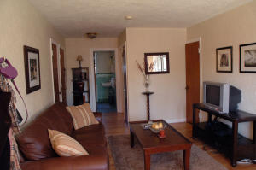

LARGE 1 bedrooms--$845/mo.
Garden level, 1 bedrooms --$725/mo.

